**Kalia Institute SCO 184 (Top Floor) Sector 37 C Chandigarh 9815439805,0172-2628742**

Work, Energy and Power

**Physics**

**Work Energy Theorm for a particle**

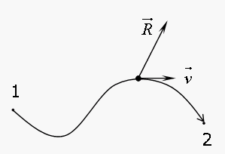

Consider a particle of mass `m’, moving under the action of several forces, having a resultant $\vec{R}$, in an arbitrary locus. Let it undergo a differential displacement during a time interval dt equal to : $\vec{ds}$ = $\vec{v}$. dt . Then applying Newton’s Law in the tangential Direction , we obtain:

$\vec{R}$. $\hat{v}$ = ( $\sum{{\vec{F}}_{i}}$) . $\hat{v}$ = *m $\frac{dv}{dt}$* = *m*. $\frac{dv}{ds}$. $\frac{ds}{dt}$ = *m. v. $\frac{dv}{ds}$*

⇒ ( $\sum{{\vec{F}}_{i}}$) . (ds. $\hat{v}$) = ( $\sum{{\vec{F}}_{i}}$) . $\vec{ds}$ = m v. dv